4/18/2018

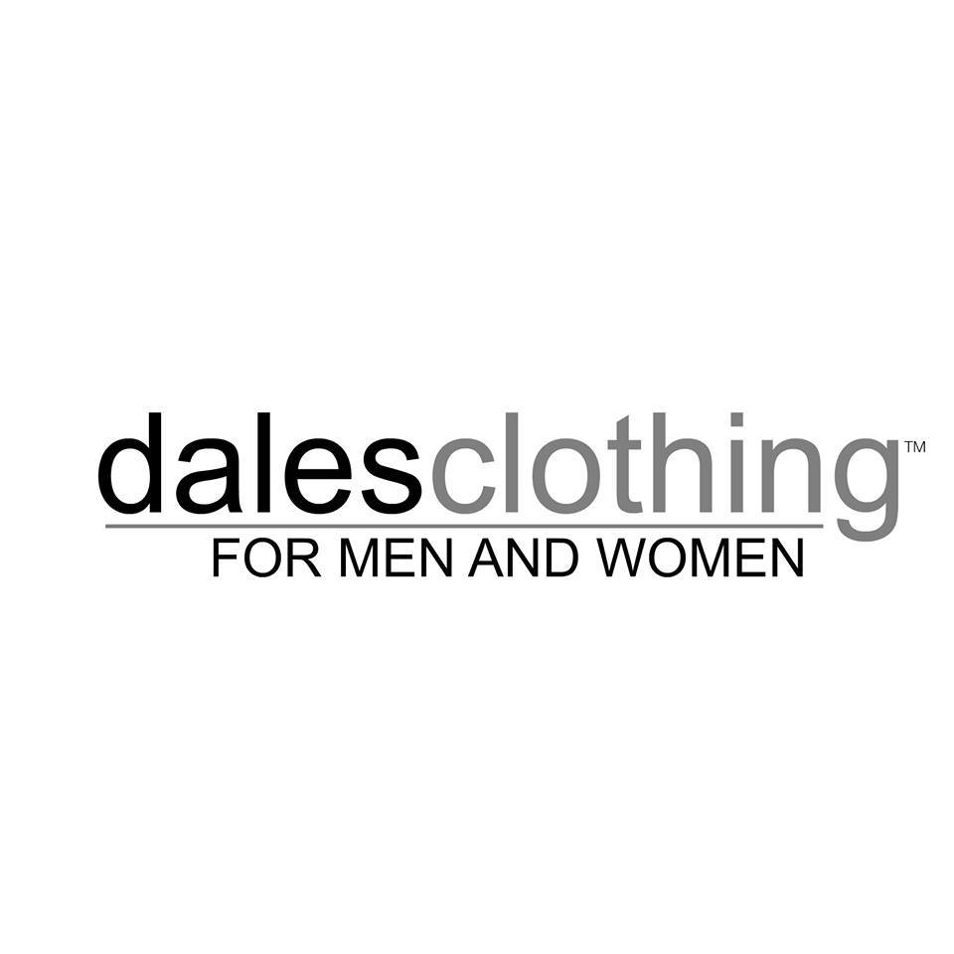

Presented by Western Technical College Marketing Research Class Austin Hass, Bryce Schiffman, and Kollin Burckhardt

**Table of Contents**

Step 1 – Formulating the Problem or Opportunity ------------------------------ 2

Step 2 – Research Design -------------------------------------------------------------- 5

Step 3 – Data Collection Method ---------------------------------------------------- 6

Step 4 – Creating the Survey ---------------------------------------------------------- 7

Step 5 – Sampling Plan ----------------------------------------------------------------- 9

Step 6 – Data Collection Process --------------------------------------------------- 10

Step 7 – Analysis Plan ----------------------------------------------------------------- 11

Step 8 – Conclusion & Recommendations --------------------------------------- 30

**Step 1 – Formulating the Problem or Opportunity**

**Introduction**

KBA Consulting is a group of marketing students at Western Technical College made up of Kollin, Bryce and Austin. Through our marketing research class, we are hoping to gain knowledge of real world experiences through working with local businesses. We are looking for an opportunity to find information for a business to help identify decision-making information for improvements. As a result, it will not only hopefully leave us with a good grade in the class, it will help us gain knowledge in the marketing research field to progress towards our future.

**Company**

Dales Clothing is a boutique retail clothing store for men and women. They specialize not only in urban clothing options but offer the opportunity of helping you find an outfit that is a good fit for you. Dales offers honest individual styling to ensure a perfect fit for special occasions and everyday life. The owner Dale Berg has had his clothing store in business for 37 years and is currently located at 121 4th Street South, La Crosse Wisconsin 54601. Roughly offering one-third skate clothes, one-third causal clothing, and one-third business attire. They have the apparel you want from trending jeans, casual fashions, and high-quality brand names to fit into your lifestyle.

The urban clothing store downtown offers one-third skate clothes, one-third causal clothing, and one-third business attire. They have the apparel you want from trending jeans, casual fashions, and high-quality brand names to fit into your lifestyle. A few brands they carry include Free People, Bailey44, Miss Me, MINKPINK, G-Star, Cookies, LRG, DOPE, HUF, RVCA, and many more. Dales Clothing has a website which is used as a landing page for brief information on his business and links to his social media accounts. He provides four different types of social media accounts. All of his active social media accounts are targeted towards his customers with each carrying a more specific target. His account on Facebook has a vast variety of reach but primarily targets adults in the age range of 30 to 60. He has two Instagram accounts that are separated into two segments, one being his general store account that provides content towards a younger audience of ages 14 to 25 whom are primarily women. The second one being a males Instagram page to accommodate his interest of growing men customers throughout the store. Lastly, he maintains a Twitter account to also target the audiences of younger males and females.

**Customers**

Dales Clothing’s main customers are currently men and women 20 to 60 years old. People usually spend 25 minutes to 1 hour in the store. According to Dale the client base is 70 percent women and 30 percent men. Most of the customers are either repeat customers or ones who come in while visiting the downtown La Crosse area. The younger teens who come in the store usually bring parents who have the buying power while college students usually come in alone or with friends mainly for the sales or deals because their buying power is limited due to a college budget. Other customers would be adults who come in to the store with their partners, self, friends, etc. and usually possess a higher option of purchasing within the store simply because of their status. (Job, income, lifestyle, etc.)

**Competitors**

According to Dale, all downtown competitors are more help to Dales Clothing than competition. They help bring customers to the downtown area and they come to Dales Clothing when they can’t find the right clothing located at the competitors’ stores like; Touch of Class, The Willow, A&S Clothing Company. Stores like the Buckle and Urban Outfitters are other main competitors as they offer similar clothing options with online services and do not generate traffic to downtown La Crosse where Dales Clothing is located. The Buckle also has a physical store at the Valley View Mall, approximately seven miles away. Choosing to shop at the mall or come downtown is a deliberate choice due to the distance between them.

**Collaborators**

Collaborators includes any wholesale providers that sell product to Dales Clothing at a wholesale price. These collaborators can affect the outcome of his business by which brand product he carries and how it is received. Each wholesale provider can benefit the company by providing the company with the latest information on what is currently a favorite product (in other words “what’s hot”). They also can contribute by offering a reasonable wholesale price so that Dales Clothing can make a good return on investment for each product sold, as well as listing Dales Clothing as a store location on their website. Some Collaborates of Dales Clothing are: RVCA, Baileys44, Obey, Pink Dolphin, Cookies, HUF Worldwide, and Free People.

**Context/Climate**

The climate of the market is always changing and keeping up with the trends is critical to a business’s success. In the case of retail clothing, this has never been more prevalent. For example, if one brand is super popular at a certain time, you’ll want to make sure you carry it, and make sure your customers know you carry it. When you offer products for several customer segments, you often have several trends for each segment, meaning you must constantly be up to date in multiple desired styles to be successful.

Not only are trends within a company’s product line important, but also trends in the economy and daily activity of the target market. Obviously if the economy is bad, you’ll likely have less sales of high end fashion items. Trends for males and females happening in the economy right now would be:

**Male Trends** **Female Trends**

-Denim Jeans -Denim Jeans

-Retro Sportswear -Simple stripes

-Vertical/ Side-Stripe Shirts -Bright Whites

-Tropical Print Shirts -Fresh Florals

What your customers do in their everyday lives is crucial when you decide how to market to them. These days, just about everyone is online, meaning you must have a very strong online presence. This includes a need for a strong website and social media accounts. Being able to attract the right customers is just as important as having the right products.

**Key Information**

According to Dale the client decision problem is looking to find the best way to reach the younger male segment of the company. Dale is trying to equalize his business sales between men and women who buy at his store.

**Possible Research Problems**

* Maybe Dale Clothing is not bringing in the rights brands to bring in the targeted segment for teenage men
* Maybe the clients are not hearing about the products Dales offers at his store
* Maybe the target market doesn’t know where Dales Clothing is located
* Maybe Dales Clothing is not effectively using social media to communicate with his desired audience
* Maybe Dales Clothing not posting the right pictures online to bring in the target market

**Research Objective**

The objective of our research is to determine the best way to communicate with his desired audience and determine what motivates them to shop for fashion in the clothing stores.

**Information Needed**

* What social media accounts to use
* What young males use for preferred communication
* What content will bring in young males
* What products to market
* What new products to bring in
* Demographic
* Motivation factors for clothes shopping
* Spending/product trends

**Step 2 – Research Design**

There are two different types of research that we will use to determine the design of this research project.

**Exploratory Research**

* Exploratory research is research conducted to find out as much as we can about Dales Clothing by finding information on the five C’s. The five C’s that were introduced in step one, contain information on company, customers, competitors, collaborators, and context of Dales Clothing. With this exploratory research we will find information by using common google searches, databases, and an interview with Dale (owner) to discuss what customer bases he has established.

**Descriptive Research**

* Descriptive research is used to answer the who, what, when, where, why and how for demographic and lifestyle characteristics of customers. For this method we plan to conduct a survey to find out what material Dales Clothing can create for their business. Through certain questioning techniques, we will offer a limited set of answers to best find results on how to bring in more consumers around the desired target audience.

**Step 3 – Data Collection Method**

For us to acquire the information needed for our marketing research, there are two types of collection methods we plan to use.

**Observation** does not involve questions but rather focuses on watching individual’s behaviors when interacting with their decision-making process when purchasing clothing commodities at clothing stores. **Communication** involves questioning respondents to answer particular questions through the use of a certain data collection method, called a questionnaire and or survey.

**Observation Research:**

To use observation research we would go to clothing stores similar to Dales Clothing. These stores would be of various trends ranging in more urban to boutique style of clothing where observations could be performed. Some of these stores may include:

* Dales Clothing
* Buckle
* Duluth Trading Company
* Rue21

At these locations we would casually study the behavior of men (ages 15-24) and how they interact with the commodities in the store. We would focus on the characteristics of each individual. For example, whether the target is shopping with friends, siblings, parents, significant other, etc. Other actions we would take note on is if they shop in certain areas of a store that carries a particular brand, if they’re always focused on price tags, if they try on several items versus one or two, if they seek for other’s approval, or if they actually make a purchase. With these observations, we look to better understand the customers and discover trends in what they appear to like and dislike, as well as other behaviors that can influence their buying process.

**Communication Research:**

Communication research will be our primary data collection method for our research. In this process, we are going to create a questionnaire survey and distribute both email and in person. We decided on a survey because we can control the questions and answers based on what we need to know and what we think the people taking the survey will say. Surveys are also fairly quick and easy which helps in getting more people to participate. Types of questions we will include will be related to:

* Demographics
* Motivational factors for clothes shopping
* Spending/Product trends
* What social media accounts to use
* What young males use most for preferred communication
* What content will bring in young males
* What specific products or brands to market or bring in

We feel that determining these factors will help us determine the proper way to reach the target market within Dales Clothing.

**Step 4 – Creating the Survey**



**Step 5 – Sampling Plan**

The target population for Dales Clothing consists of college students around the campuses of La Crosse, WI. The campuses in which we will be conducting the survey at are Viterbo University, Western Technical College, and UW-La Crosse. The target population of interest are the students around the campus who are looking for more urban types of clothing and would consider shopping at Dales Clothing. For our survey, we are using a non-probability convenience sample which will be conducted at the libraries or cafeterias of the campuses. We are using the convenience sample because of its easily obtained access and relation towards other college students.

For our operation schedule, we are planning on conducting the surveys on the week of March 26, 2018 through April 6, 2018. In casual-wear attire, we will go to these locations in the afternoon/evening around 3-8P.M. during the week, as we feel that the most students are at these locations during this time. We will approach a majority of men for our survey but will still provide the survey to women as well. To intrigue their interest of taking our survey, Dale has offered us with the option to give them 40% off any one item (excluding dresses) to use within his store.

**Step 6 – Data Collection Process**

On March 20th, we began to brainstorm questions for our survey. We came up with about 20 questions that fit on two pages or the front and back of one page. We gave this to our instructor, Shelly, to look over and give us feedback. Over the next week, we spent time revising our survey and giving it back to Shelly for feedback. Once we had our revised survey, we took it to Dale on March 28th to get his approval as well as feedback and questions he specifically wanted to know about. After receiving Dale’s approval, we made a few final revisions and then gave out a handful of preliminary surveys to students and parents to get their reaction and feedback on it. After completing, revising, and finalizing our survey, we had total 18 questions with 15 required. This was due to the respondent’s answer on question 15 dictated whether or not they had to complete questions 16-18.

We began to hand them out to students and staff around the area on April 2nd. The main idea here in collecting the data was to find trends and analyze customer behavior. We then used those findings in the report to help Dales Clothing in better targeting the young male segment. As stated before in Step 5, we used a 40% off coupon to Dales as an incentive to take the survey. We began on the first day by targeting the immediate people we see every day, roommates, neighbors, classmates, professors, etc. From April 3rd-6th, we began targeting the general population of Western’s campus. We handed out surveys at the Student Union, Residence Hall, Library, classrooms, and staff offices. We got most of our surveys completed at the Student Union, where we tried to hand them out around the peak times when students were eating. This included the evening rush from about 5-7pm and the lunch rush from 11-12:30.

In all, we got a total of 91 surveys completed. We had about a 33% refusal rate due to about one out of every three people we asked to complete the survey refused to take it. We only excluded one survey from our final count and results due to the respondent not providing enough valid information.

We ran into a slight issue with the perceived length of pour survey. While it actually would only take people around 3-6 minutes to fill it out completely and thoroughly, at first glance it looks fairly extensive. We believe this is due to it consisting of more than one page and the fact that about half of the questions required more than one answer or had multiple sub questions within them. This caused a few respondents to rush through it and either not respond fully to some questions or in a handful of cases, not respond to certain questions at all. For a majority of the respondents however, this was not an issue and they filled it out completely and thoroughly.

We believe the results and data we received has helped us better understand how people buy clothes and about clothing customers in general. This will help us to help Dales Clothing in their overall goal to target young men and accommodate to their trends and behaviors.

**Step 7 – Analysis Plan**

Each aspect of this marketing research step will give us a more in depth look of the meaning behind each individual answer and how they correlate with one another. The following are descriptions of the various data analytical techniques used when determining the results of the questions used on the survey.

***Questions 1, 2, 3***

The response to these three questions will help us to understand the demographics of each person that took the survey. We will label this as the demographic section of questions.

***Questions 5, 6, 14, 15, 16, 17***

Frequency analysis will be our primary interpretation of data provided by these questions. When asking these questions will we organize each answer into a specific category. Each answer will allow us to put data into creating histograms to show the variety of results received.

***Question 4***

Descriptive statistics describe the distribution of responses on a variable. We will use this with a ranking method of 1 through 5 answers on each variable to conduct results.

Cross Tabulation method is an important tool for study the relationships between two (or more) categorical variables. We will use this method to cross tabulate question 4 to questions 1, 2 and 3 to determine the relation of which users are using what particular social media.

***Question 5***

Looking to understand what reasons people are motivated to go shopping for new clothes.

Cross tabulation method will be used with the demographics questions (1, 2 and 3) to determine the difference in answers compared to an individual’s demographics.

***Question 7***

This question would also be a frequency type question divided into each category within the answer. Our answers range from “always, almost always, sometimes, almost never, and never.” These questions will allow us to understand how the majority of shoppers choose to shop.

Cross tabulation method will be used with the demographics questions (1, 2 and 3) to determine where each type of customer chooses to shop.

***Question 8***

Descriptive research on this question will be used to determine the rankings of each variable. Ranking from 1 being “Not important” to 5 being “Very important” will help us to understand the value of each category.

Cross tabulation method will be used with the demographics questions (1, 2 and 3) to determine what options are important to each type of customer.

***Question 9, 10***

Two-Box technique is use for converting an interval-level rating scale into a categorical measure. We will use this technique to determine the top two position ratings on the scale of answers provided.

***Question 11, 12***

These questions will be cross tabulated with each other. We want to understand the relationship between the brands they prefer to wear, to the clothing stores that they choose to shop at.

***Question 13***

This open-ended question will help us provide insight on what reasoning’s there would be for people to not buy an article of clothing. We will list each individual response to view the variety of answers received.

***Question 14***

Cross tabulation method will be used with the demographics questions (1, 2 and 3) to determine the difference on who individuals shop with more frequently depending on their demographics.

***Question 15***

This question is created to ask the survey takers weather they have heard of Dales Clothing. It is simply a transition question to inform the users whether or not to continue onto questions 16 through 18.

***Question 16***

Looking to understand the most common way individuals have heard about Dales Clothing.

***Question 17***

Looking to understand where the most individuals have heard of Dales Clothing through social media to determine which type is most effective.

***Question 18***

A histogram will be applied to this frequency question to determine the scale rating of an individual’s experience when shopping at Dales Clothing.

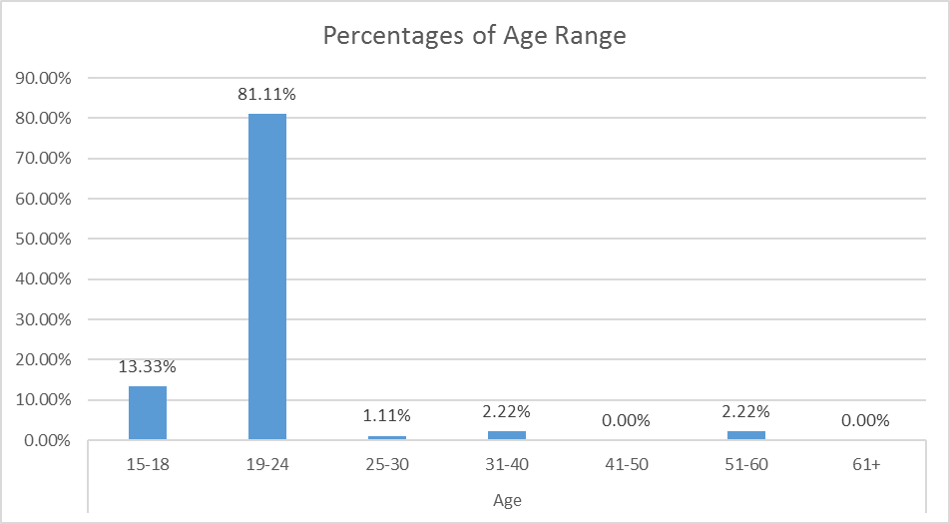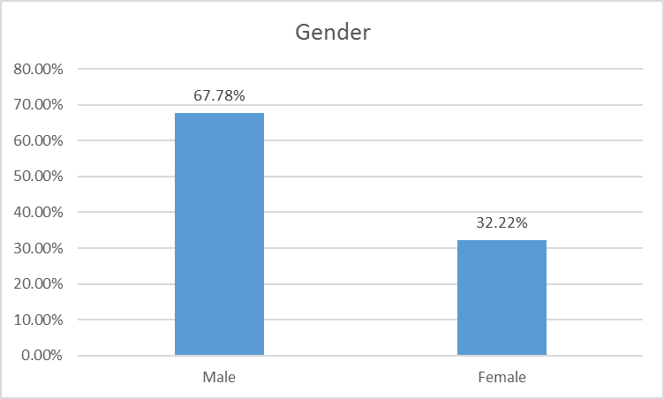

Question 2

Question 1

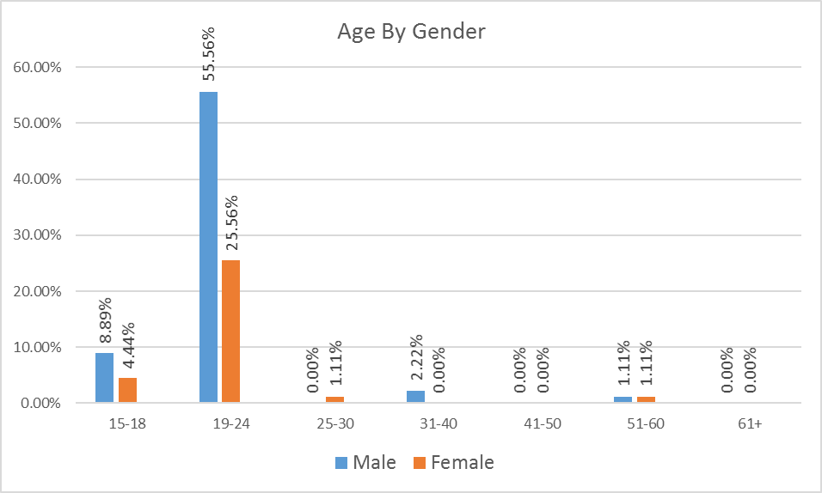

Question 1 & 2 Cross Tabulation: This graph shows a result of the amount people that took our survey based on their gender.

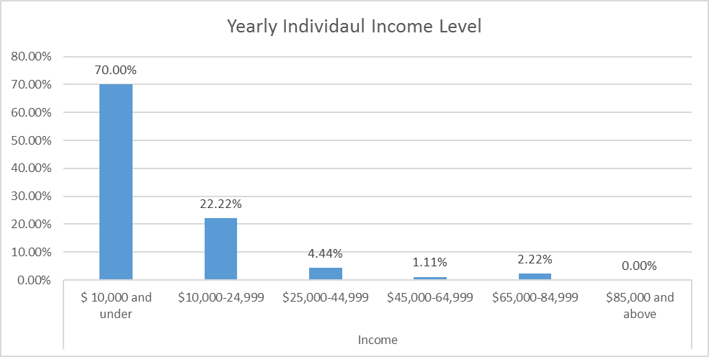

Question 3

Question 4: This chart shows the ranking scale from 1 to 5 for social media preference. Our results showed: Snapchat – 1, Instagram – 2, Twitter – 3, Facebook – 4, Pinterest – 5. (1 being used the most, 5 being used the least)

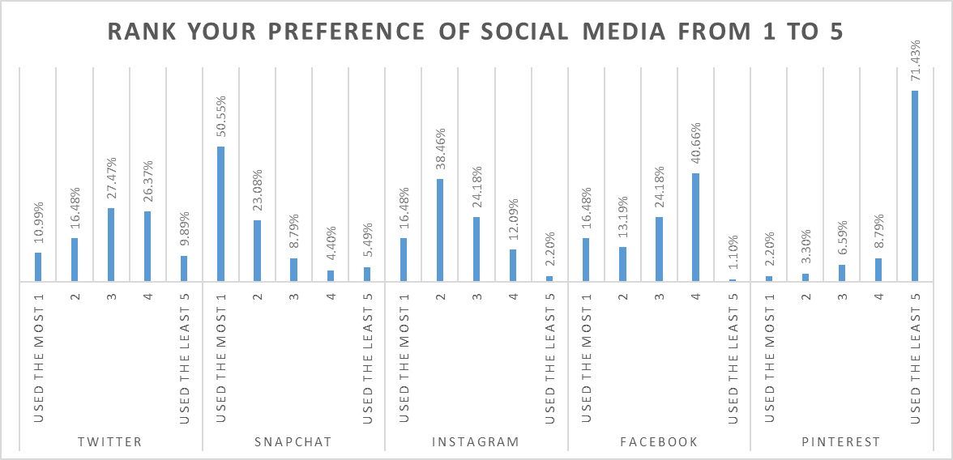

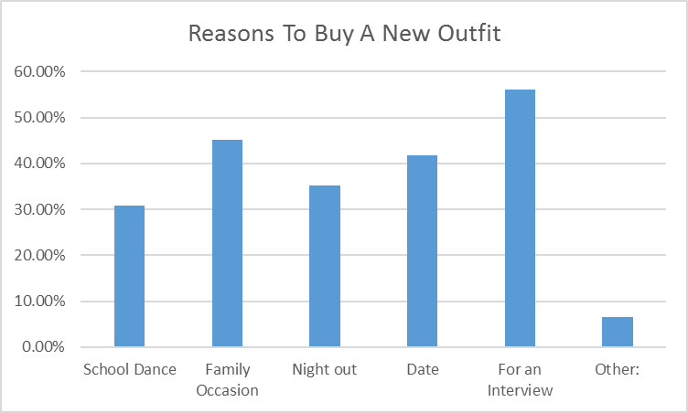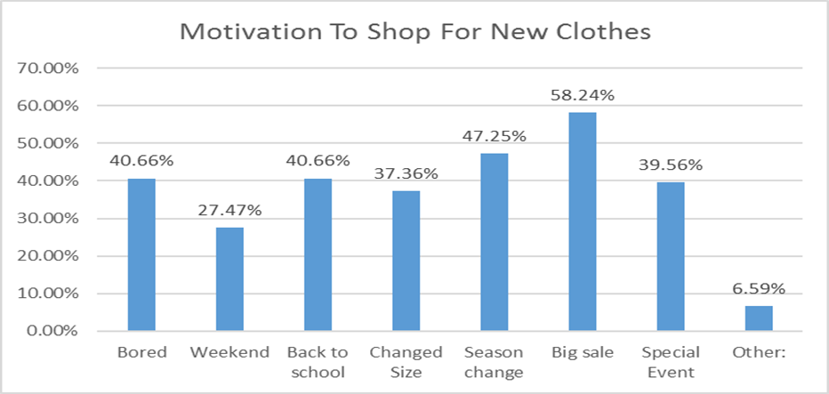

Question 6: This graph narrows the results on why respondents choose to buy a new outfit. Some other options would be: vacation, funeral, trip, holidays, meetings, camping, etc.

Question 5: This Graph shows that a big sale is a majority favorite when it comes to shopping for new clothes. To our surprise we noticed that being bored also played a significant role on motivation to buy clothing. Our other categories ranged from clothing wearing out/ getting old, significant other wants to go shopping, have extra money, necessity, etc.

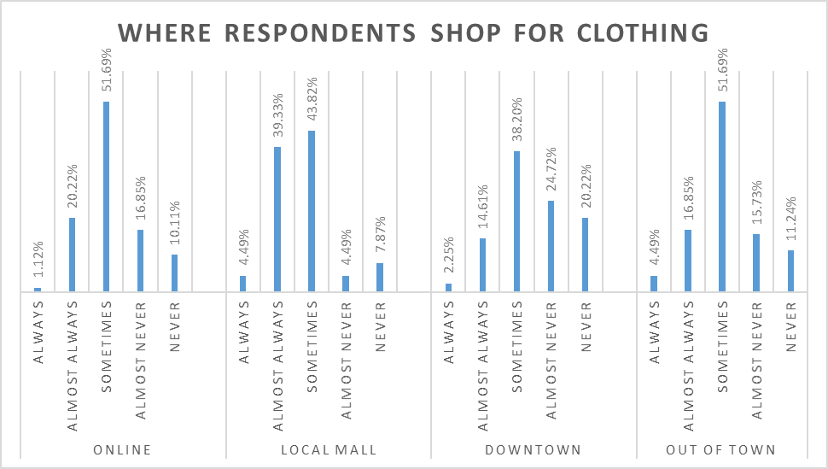

Question 7: This chart shows where respondents shop for clothing. Each category is ranked highest in the sometimes to almost always sections. We were surprised to see online shopping with a 10.11% rate of never.

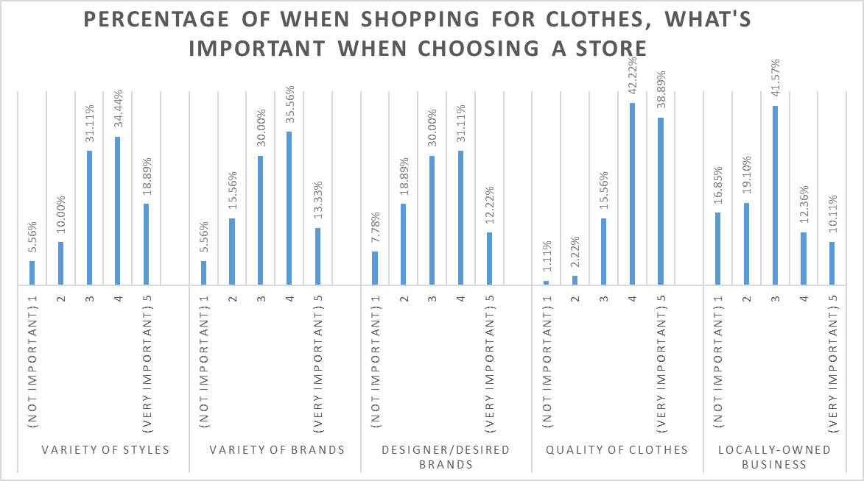

Question 8: The next two charts show the results of importance when respondents choose to shop. We were not shocked to see low prices being the number 1 importance which was closely followed by the quality of clothing.

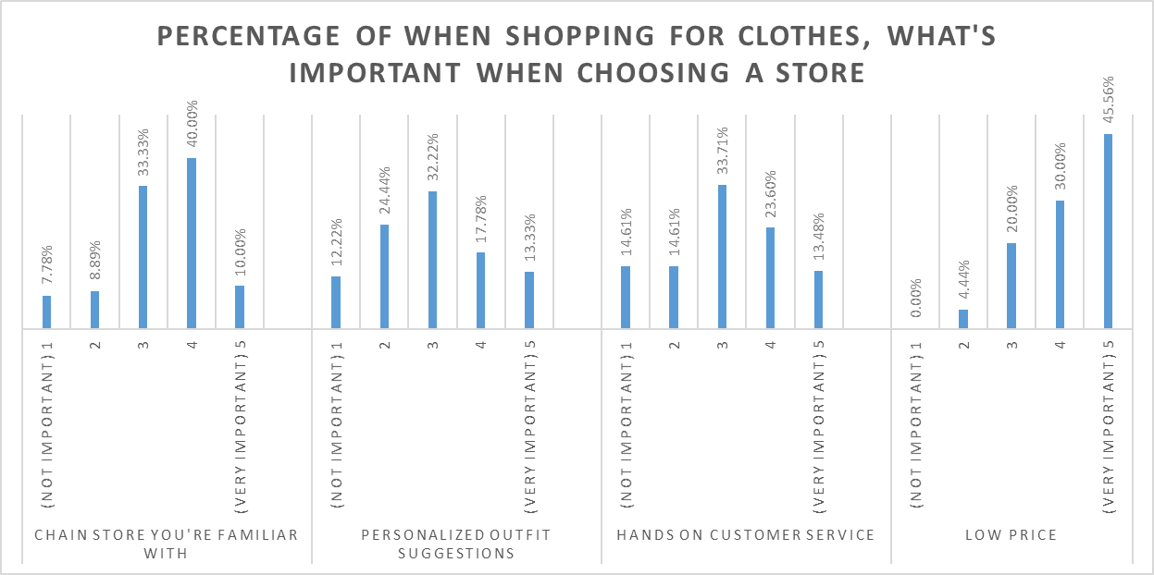

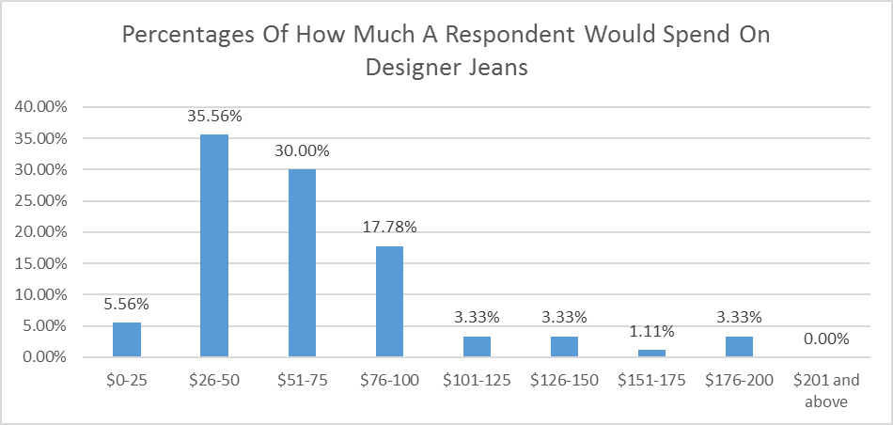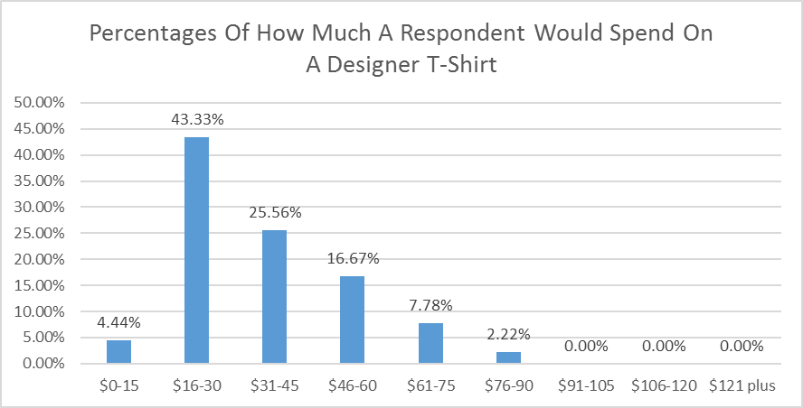

Question 10: This graph shows that the overall average designer jean respondents would pay would range from $26 to $75. With a small segment still available in paying the $76-$100 range, there is a significant decrease in users willing to pay over $100.

Question 9: This graph shows that the overall average t-shirt price respondents would pay would range from $16 to $45.

Question 11: This list of responses are all the answers respondents wrote down when asked for which clothing stores they usually shop at. The most popular stores respondents asked with were: American Eagle, Buckle, Walmart.

|  |  |  |
| --- | --- | --- |
| What Top 3 Clothing Stores Do You Usually Shop At? | | |
| Response 1 | **Response 2** | **Response 3** |
| Buckle | Gander | No Answer |
| Forever 21 | Urban Outfitters | Missguided |
| TJ Maxx | Zumiez | Pacsun |
| American Eagle | Buckle | Dry Goods |
| Nike | Pacsun | Zumiez |
| Target | Kohls | Amazon |
| TJ Maxx | Kohls | Scheels |
| American Eagle | Kohls | Dicks Sporting Goods |
| Old Navy | American Eagle | Target |
| American Eagle | Kohls | No Answer |
| TJ Maxx | American Eagle | Ross |
| Nike | Farm and Fleet | American Eagle |
| American Eagle | No Answer | No Answer |
| Buckle | Victorias Secret | American Eagle |
| American Eagle | Kohls | Buckle |
| American Eagle | Kohls | Forever 21 |
| Shopko | Dicks Sporting Goods | Ross |
| Nike Outlet | Dicks Sporting Goods | Marshalls |
| JC Pennys | Maurices | American Eagle |
| American Eagle | Kohls | Maurices |
| Gap | Aeropostale | Hollister |
| Farm and Fleet | Duluth Trading Co. | Eddie Bauer |
| Ross | JC Pennys | No Answer |
| Kohls | Dicks Sporting Goods | Outlet Mall |
| TJ Maxx | Ross | Nordstram |
| Ross | JC Pennys | TJ Maxx |
| Macy's | Herberger's | Sears |
| JC Pennys | Kohls | Walmart |
| Hollister | No Answer | No Answer |
| Target | JC Pennys | Walmart |
| Francescas | American Eagle | Hollister |
| Walmart | American Eagle | Hollister |
| American Eagle | Forever 21 | No Answer |
| Outlet Mall | Kohls | JC Pennys |
| Gander Outdoors | No Answer | No Answer |
| Target | Walmart | Gander Outdoors |
| Old Navy | TJ Maxx | Goodwill |
| Buckle | Express | No Answer |
| Dicks Sporting Goods | Ross | No Answer |
| Goodwill | Shopko | Farm and Fleet |
| Goodwill | Salvation Army | No Answer |
| Kohls | Outlet Mall | Target |
| Kohls | Walmart | Outlet Mall |
| Walmart | Kohls | Platos Closet |
| Victorias Secret | Rue 21 | Zumiez |
| Francescas | Rue 21 | Goodwill |
| Shopko | Amazon | Walmart |
| Shopko | Kmart | Payless |
| TJ Maxx | Foot Locker | Old Navy |
| Nike | American Eagle | Foot Locker |
| Hot Topic | Walmart | Kohls |
| Macys | No Answer | No Answer |
| Hot Topic | Goodwill | No Answer |
| Shopko | Walmart | Goodwill |
| GAP | Eddie Bauer | TJ Maxx |
| TJ Maxx | JC Pennys | Kohls |
| American Eagle | Aeropostale | Old Navy |
| JC Pennys | Walmart | No Answer |
| Rue 21 | Kohls | American Eagle |
| Banana Republic | Old Navy | No Answer |
| Express | JC Pennys | Kohls |
| Macys | Mens Warehouse | JoS. A. Bank |
| American Eagle | Target | Kohls |
| Platos Closet | American Eagle | Apricot Lane |
| American Eagle | No Answer | No Answer |
| Goodwill | No Answer | No Answer |
| TJ Maxx | Footlocker | No Answer |
| American Eagle | Charlote Russ | Aeropostale |
| Ross | JC Pennys | Kohls |
| Target | Scheels | American Eagle |
| TJ Maxx | Buckle | American Eagle |
| Macys | American Eagle | Nordstorm |
| Duluth Trading | American Eagle | Hollister |
| H and M | Goodwill | Kohls |
| Buckle | American Eagle | No Answer |
| American Eagle | Forever 21 | No Answer |
| Zumiez | Thriftshops | No Answer |
| Dicks Sporting Goods | Kohls | No Answer |
| Old Navy | Buckle | American Eagle |
| American Eagle | Carhartt | Mall |
| Buckle | Victorias Secret | American Eagle |
| Kohls | Victorias Secret | Buckle |
| Kohls | Mall | No Answer |
| Mall | No Answer | No Answer |
| Buckle | American Eagle | No Answer |
| American Eagle | No Answer | No Answer |
| Duluth Trading | Kohls | Mall |

Question 12: This list of responses are all the answers respondents wrote down when asked for which clothing brands they usually shop for. The most popular brands out of this list were: Nike, Adidas, and Under Armour.

|  |  |  |
| --- | --- | --- |
| What Top 3 Clothing Brands Do You Prefer To Wear? | | |
| Response 1 | **Response 2** | **Response 3** |
| Nike | Under Armour | No Answer |
| Calvin Klein | American Eagle | Victorias Secret |
| Pink Dolphin | Timberland | Tommy Hilfinger |
| American Eagle | No Answer | No Answer |
| Jordan | Nike | Calvin Klein |
| Nike | Under Armour | No Answer |
| Levi | Nike | Under Armour |
| American Eagle | Adidas | Nike |
| Madewell | Patagonia | Old Navy |
| Nike | American Eagle | No Answer |
| American Eagle | Old Navy | Calvin Klein |
| Nike | Under Armour | American Eagle |
| Nike | Majestic | New Era |
| Nike | Under Armour | Pink |
| Rock Revival | Miss Me | No Answer |
| Adidas | Nike | American Eagle |
| Nike | Under Armour | Adidas |
| Arizonia | St. John Bays | No Answer |
| American Eagle | No Answer | No Answer |
| Nike | Carhartt | Calvin Klein |
| Adidas | No Answer | No Answer |
| Nike | Under Armour | Old Navy |
| Brand less important than style | No Answer | No Answer |
| Nike | Adidas | Levi |
| Teddy Fresh | Nike | Adidas |
| Nike | Under Armour | Hollister |
| Nike | Canvas | Hollister |
| Nike | Calvin Klein | Free People |
| AND1 | Nike | Under Armour |
| American Eagle | No Answer | No Answer |
| Nike | Reebok | Under Armour |
| Lucky | Nike | Under Armour |
| Levi | Nike | Under Armour |
| Nike | Old Navy | Jordan |
| Nike | Under Armour | Express |
| Nike | Adidas | Under Armour |
| Justin | No Answer | No Answer |
| Rue 21 | No Answer | No Answer |
| Adidas | Nike | No Answer |
| Nike | Under Armour | Adidas |
| Aeropostale | Pink | No Answer |
| Nike | Adidas | Calvin Klein |
| Nike | Under Armour | Adidas |
| Nike | Adidas | Sketchers |
| Nike | Jordan | Adidas |
| Nike | Jordan | American Eagle |
| Adidas | Nike | Under Armour |
| Nike | Polo | Burberry |
| Nike | Adidas | Under Armour |
| Happy Tree | Penguin | No Answer |
| American Eagle | Aeropostale | Old Navy |
| Nike | Under Armour | No Answer |
| Adidas | Old Navy | No Answer |
| Express | Under Armour | Van Hausen |
| Kuhl | Under Armour | No Answer |
| American Eagle | Hollister | Eddie Bauer |
| American Eagle | No Answer | No Answer |
| Nike | Under Armour | American Eagle |
| Carhartt | Volcom | No Answer |
| Nike | Adidas | Hurley |
| Nike | Under Armour | Adidas |
| American Eagle | Calvin Klein | Ralph Lauren |
| Nike | No Answer | No Answer |
| Nike | Adidas | American Eagle |
| Nike | No Answer | No Answer |
| American Eagle | Gymshark | No Answer |
| Supreme | Woolrich | Patagonia |
| Nike | Adidas | Under Armour |
| American Eagle | RVCA | Urban Pipeline |
| Nike | Aeropostale | Under Armour |
| Nike | Under Armour | Fox Racing |
| Pink | American Eagle | No Answer |
| Pink | American Eagle | Nike |
| Pink | Nike | Hollister |
| Nike | Adidas | No Answer |
| Adidas | Nike | American Eagle |
| American Eagle | Urban Pipeline | Nike |
| Carhartt | Nike | Levis |

Question 13: Respondents were asked to briefly list reasons they would not buy an article of clothing. Each word listed below shows each respondents reasoning behind not buying. As we assumed, **too expensive** was 74% of the results.

|  |  |  |  |  |  |  |  |  |  |  |  |  |  |  |  |  |  |  |  |  |  |  |  |  |  |  |  |  |  |  |  |  |  |  |  |  |  |  |  |  |  |  |  |  |  |  |  |  |  |  |  |  |  |  |  |  |  |  |  |  |  |  |  |  |  |  |  |  |  |  |  |  |  |  |  |  |  |  |  |  |  |  |  |  |  |  |  |  |  |  |  |  |  |  |  |  |
| --- | --- | --- | --- | --- | --- | --- | --- | --- | --- | --- | --- | --- | --- | --- | --- | --- | --- | --- | --- | --- | --- | --- | --- | --- | --- | --- | --- | --- | --- | --- | --- | --- | --- | --- | --- | --- | --- | --- | --- | --- | --- | --- | --- | --- | --- | --- | --- | --- | --- | --- | --- | --- | --- | --- | --- | --- | --- | --- | --- | --- | --- | --- | --- | --- | --- | --- | --- | --- | --- | --- | --- | --- | --- | --- | --- | --- | --- | --- | --- | --- | --- | --- | --- | --- | --- | --- | --- | --- | --- | --- | --- | --- | --- | --- | --- | --- |
| |  |  | | --- | --- | | Briefly list reasons why you would choose not to buy an article of clothing you like: | | | Response |  | | Money | Price | | Too Expensive | Too Expensive | | Price | Didn't Fit | | Too Expensive | Too Expensive | | No Money | Too Expensive | | Too Expensive | Too Expensive | | Too Expensive | Too Expensive | | Too Expensive | Too Expensive | | No Answer | Too Expensive | | Too Expensive | No Money | | Too Expensive | Too Expensive | | Too Expensive | None | | Too Expensive | Too Expensive | | Too Expensive | Too Expensive | | Doesn't Fit | No Answer | | Too Expensive | No Answer | | Too Expensive | Too Expensive | | Too Expensive | Too Expensive | | Too Expensive | I really didn't need it | | Too Expensive | Too Expensive | | Too Expensive | No Answer | | Color | Too Expensive | | Too Expensive | Too Expensive | | Too Expensive | Too Expensive | | Too Expensive | Too Expensive | | Too Expensive | Too Expensive | | Too Expensive | Quality | | Too Expensive | Brand | | Too Expensive | Too Expensive | | Too Expensive | Doesn't Fit | | Too Expensive | Too Expensive | | Too Expensive | Quality | | Too Expensive | Too Expensive | | No Answer | Too Expensive | | Too Expensive | Too Expensive | | Fitting | Doesn't Fit | | Too Expensive | Too Expensive | | Too Expensive | Too Expensive | | Wouldn't Wear Enough | Too Expensive | | Too Expensive | Too Expensive | | Too Expensive | Doesn't Fit | | Too Expensive | Too Expensive | | Too Expensive | Quality | | Too Expensive | Closet Space | | No Answer | Too Expensive | | Too Expensive |  | |

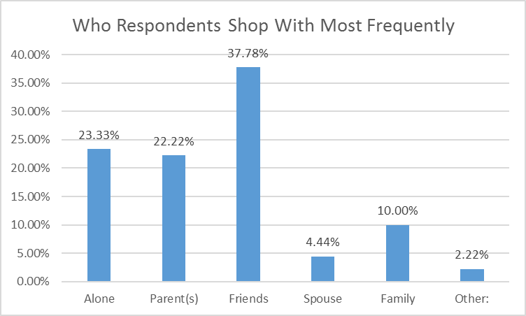

Question 15

Question 14: This graph shows who respondents like to shop with the most frequently. Because of our high numbers in age range from 19-24 we felt this was a reasoning spouse was not a high percentage as most people this age are not married. Our other category was given the option to write in an answer with all being “girlfriend.”

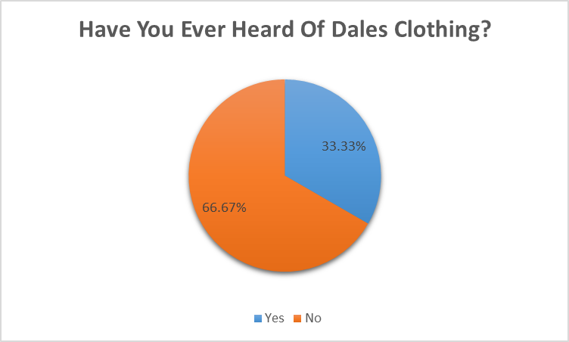

Question 16: Respondents were only asked to answer the following questions (16-18) if they answered yes to question 15. This graph shows the results of how respondents have heard of Dales Clothing. To our surprise, not one person answered with website. Our other category was given the option to write in an answer with all being “work.”

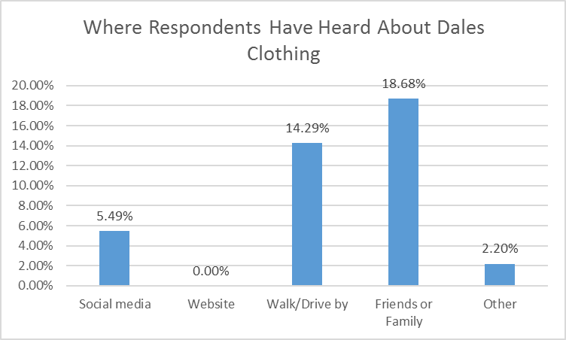

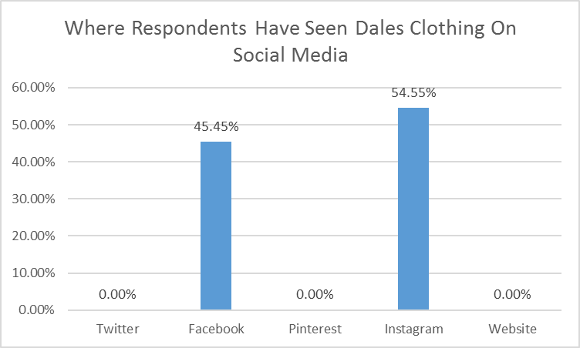

Question 17: Out of the respondents who answered yes to seeing Dales Clothing on social media, they were asked to circle all the options that apply. We were shocked to see that the only responses were Facebook and Instagram. This comes as a surprise because Dales Clothing also has a Twitter, Pinterest and Website.

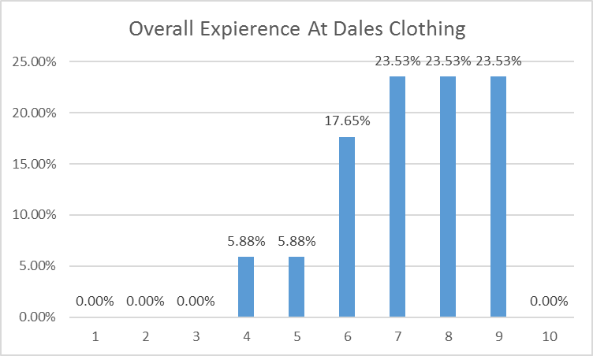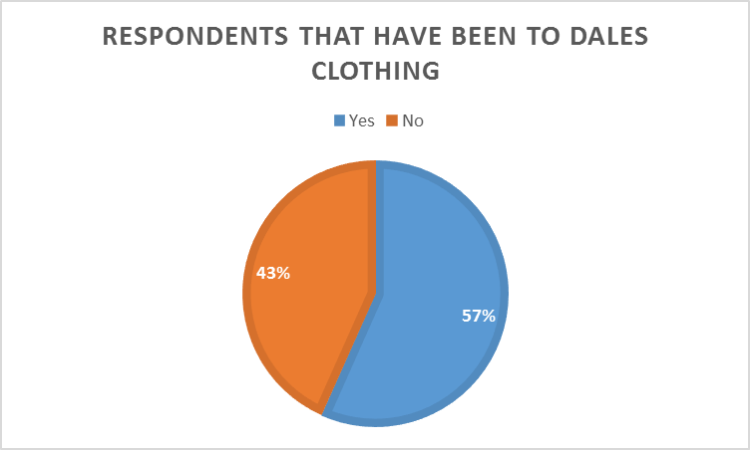

Question 18: This graph show the results respondents gave for an overall experience at Dales Clothing. With the majority ranging from 7-9, we were excited to see that no one has had a terrible experience (3 or below) when shopping at Dales Clothing.

Question 18: Respondents were asked if they have been into Dales Clothing before. If they answered yes, they were asked to rate their experience.

**Step 8 – Conclusion and Recommendations**

During our research process we believe we have found results that would be beneficial to Dales Clothing. Our conducted survey provided us with a great amount of feedback and information to help discover different ways to target not only the male segment, but a younger crowd in general. With a response rate of the 91 surveys, these results are recommendations based off of knowledge gained within our marketing classes. We are not professionals, but we are looking to create an improvement to Dales Clothing to benefit his business, while learning new skills in marketing research.

Through our survey of the 91 respondents, we received a response from 68% male and 32% female. While specifically targeting a younger segment, our findings were made up of; 13% ages 15-18, 81% ages 19-24, and a cumulative percent of 6% ranging from the ages 25 and up. Not to our surprise, 70% of the respondents were having an annuals income of $10,000 and under. Beyond this, 22% were in the category of $10,001 to $24,999, with a cumulative percent of 8% ranging in different categories from $25,000 and up. With these demographics in mind, we have summarized the results found within our marketing research.

* Respondents are most motivated to shop for new clothes when there is a big sale or a change in season. Other top ranked options are back to school and simply just bored.
* From the list on our survey (question 6) respondents chose “For an Interview” and “Family Occasion” as a top response for a reason to buy a new outfit.
* The highest percent price range we recorded individuals would pay for a designer t-shirt would be $16-$30. While this was the highest in percentages, individuals were still willing to pay more up until about reaching $60. Anything over this is where it dropped to less than 10% of people willing to pay.
* The overall average price range we recorded individuals would pay for pair of designer jeans would range from$26-$75. With a significant decrease on individuals paying over $100, we found that roughly 10% of the respondents were still willing to pay over the $100.
* 73% of respondents’ reason for not buying an article of clothing was because the price was too expensive.
* Top Brands people associated themselves in liking were Nike, Adidas, and Under Armour. We feel that this is particularly because of the recognition of the well-known brand.

When asked for opinions on what options individuals look for when choosing a store to shop at, we found the following as the most important; low price, quality of clothes, designer/designer brands, and variety of brands. We feel that bringing in a quality clothing from a well-known brand would be recommended for Dales Clothing. We understand that Dales Clothing has great options when it comes to quality of clothes, but we believe that younger males and/or females are not familiar with certain brands that Dale carries which might make them more hesitant to buy.

Relating to the types of well-known brands that the young male segment might be more familiar with. By viewing the types of clothing currently in the store in correlation to what is offered to females, we believe that there needs to be a more similar aspect when choosing clothing options for the male population. What we mean by this is that the females’ side is recognized by higher-end trendy brands and the male side is made more up of skater type clothing. While these options in clothing styles can reach the younger male segment indefinitely, we feel that this is limiting the target to only that particular segment. A recommendation we would like to bring attention to is bringing in more types of clothing that are based on well-known casual wear for everyone. While the attention of this is to not target everything towards this simple clothing wear, we feel it is a good base to get the younger male segment into the door because of their familiarity of what to expect in clothing. If an individual is familiar with clothing like Under Armour, Levi, Fila, Vans, Wrangler, Nike, Columbia and The North Face, it might help attract them to Dales Clothing when noticing it in the store. After getting this segment into the door, this is when you want to also have the options of designer-trendy clothes such as Calvin Klein, Tommy Hilfiger, Lacoste, Patagonia, Kenneth Cole, and Vineyard Vines. While we understand as a small local business not all these options are available, these are just some examples we created personally that we feel could be beneficial. Through this research we believe that bringing in a small selection of casual wear could help raise awareness of the urban style clothing available in Dales Clothing.

We noticed that respondents ranked Snapchat as their most preferred social media platform. While Snapchat may be popular, as a small business we feel that this platform may not be as necessary to a younger crowd. Not many users in this segment are looking to add a business on this social media. A Snapchat account may not hurt to have, but we feel that there are other platforms that could be focused on first. Following Snapchat, Instagram lead in the respondents next most used social media platform and behind that, Twitter. We feel that both of these are great ways to target this segment because of the ability to share with friends on these platforms. For instance Twitter can get a great amount of re-tweets from an individual and an Instagram post could be put in a trending category if it receives a lot of likes. Dales Clothing already has both Instagram and Twitter, however, there seems to appear a lack of interest on the Twitter platform. We noticed that most of the tweets were just pictures posted to the page. While users can view these images without a doubt, many of them are looking to come to Twitter for the short texts involved in the platform. A big hit on Twitter is the amount of funny trending tweets that get re-tweeted and liked the most that can help a company’s account be recognized. It is important to create interesting tweets for users to interact with Dales Twitter account to raise awareness of his business and ultimately bring them in to the store. While up keeping Instagram and Facebook, a Twitter campaign may be a liable option to focus on.

As a result, we hope this marketing research conducted will be beneficial to Dales Clothing. We, as a team, would personally like to thank Dale Berg for giving us the opportunity to analyze ways to improve his store by specifically focusing on targeting the young male segment. Also, we would like to thank our instructor Shelly Wetzsteon for the guidance and mentoring she provided us with along the way. As a whole, we feel we have all gained in-depth knowledge and a great understanding of the process of conducting marketing research. We look forward to carrying these new skills acquired into our future professions.